**ใบงานที่ 4 โปรแกรมเครื่องคิดเลข**

คำสั่ง ให้นักเรียนออกแบบหน้าจอตามตัวอย่าง แล้ว เขียนโปรแกรมและใส่โค๊ดโปรแกรมลงไปตามตัวอย่างที่ให้ แล้ว Save ชื่อว่า Calculator01_61 (10 คะแนน)

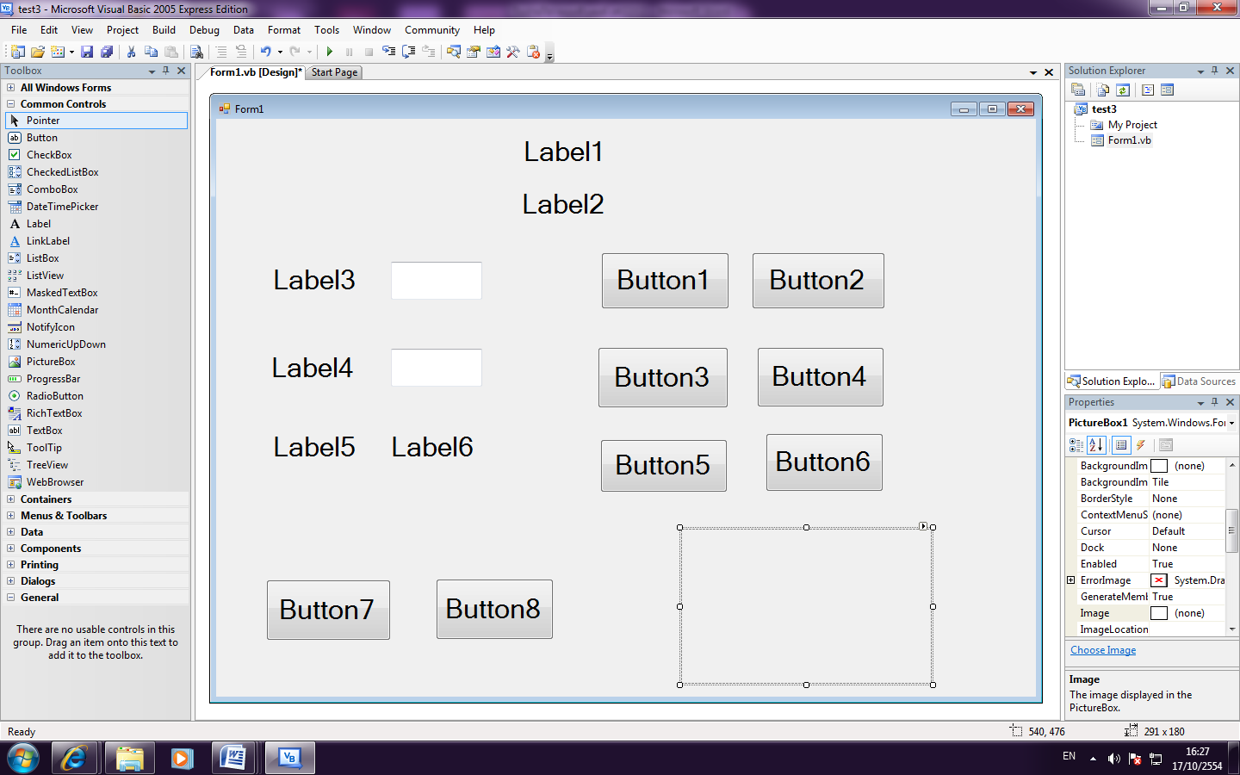

Textbox1

Textbox2

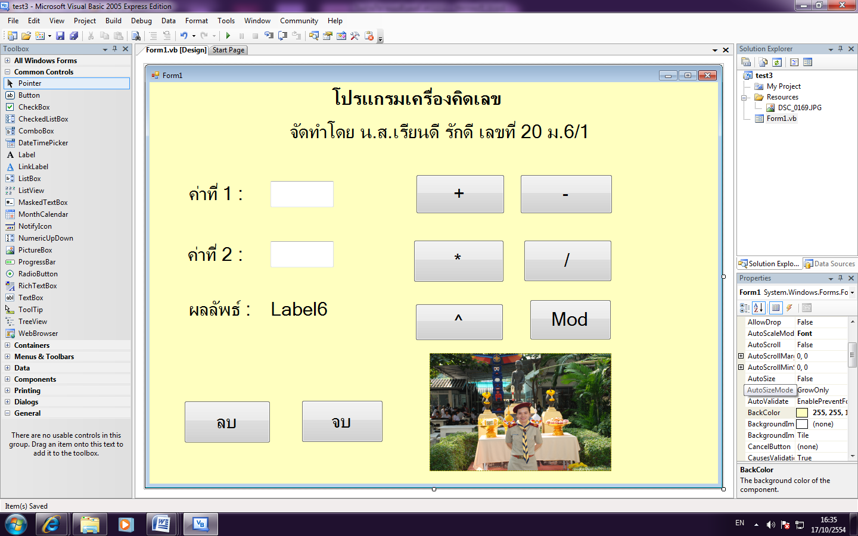

**โค๊ดโปรแกรมเครื่องคิดเลข**

Public Class Form1

**Dim operand1, operand2, result_a, result_b, result_c, result_d, result_e, result_f As Single**

Private Sub TextBox1_TextChanged(ByVal sender As System.Object, ByVal e As System.EventArgs) Handles TextBox1.TextChanged

**operand1 = Val(TextBox1.Text)**

End Sub

Private Sub TextBox2_TextChanged(ByVal sender As System.Object, ByVal e As System.EventArgs) Handles TextBox2.TextChanged

**operand2 = Val(TextBox2.Text)**

End Sub

Private Sub Button1_Click(ByVal sender As System.Object, ByVal e As System.EventArgs) Handles Button1.Click

**result_a = operand1 + operand2**

**Label6.Text = result_a**

End Sub

Private Sub Button2_Click(ByVal sender As System.Object, ByVal e As System.EventArgs) Handles Button2.Click

**result_b = operand1 - operand2**

**Label6.Text = result_b**

End Sub

Private Sub Button3_Click(ByVal sender As System.Object, ByVal e As System.EventArgs) Handles Button3.Click

**result_c = operand1 * operand2**

**Label6.Text = result_c**

End Sub

Private Sub Button4_Click(ByVal sender As System.Object, ByVal e As System.EventArgs) Handles Button4.Click

**result_d = operand1 / operand2**

**Label6.Text = result_d**

End Sub

Private Sub Button5_Click(ByVal sender As System.Object, ByVal e As System.EventArgs) Handles Button5.Click

**result_e = operand1 ^ operand2**

**Label6.Text = result_e**

End Sub

Private Sub Button6_Click(ByVal sender As System.Object, ByVal e As System.EventArgs) Handles Button6.Click

**result_f = operand1 Mod operand2**

**Label6.Text = result_f**

End Sub

Private Sub Button7_Click(ByVal sender As System.Object, ByVal e As System.EventArgs) Handles Button7.Click

**TextBox1.Text = ""**

**TextBox2.Text = ""**

**Label6.Text = ""**

End Sub

Private Sub Button8_Click(ByVal sender As System.Object, ByVal e As System.EventArgs) Handles Button8.Click

**End**

End Sub

End Class